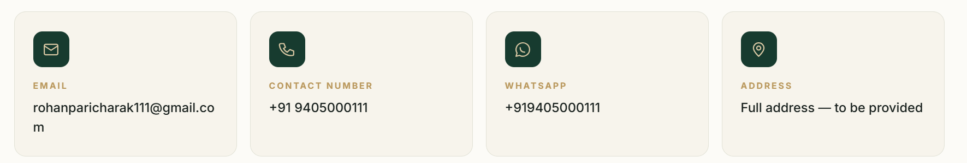
Contact number and whatsapp number will be the same so combine in in just one point box. Now add business hours details in just been empty box. Add full address which I have give in you before.
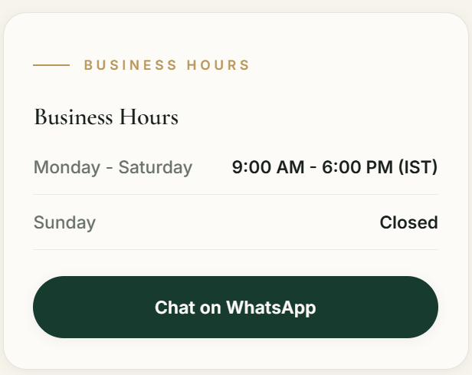
Remove this section
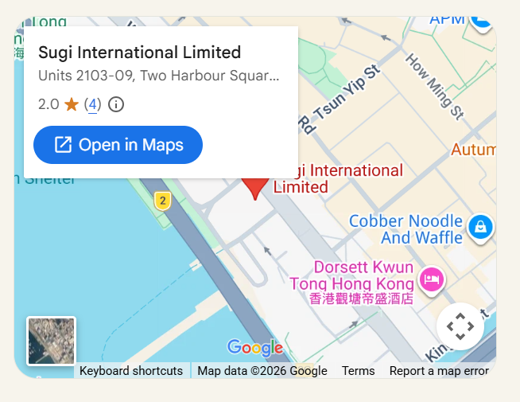
Remove this section. This map looks more professional can you replace the map you provided in the footer with this map format?
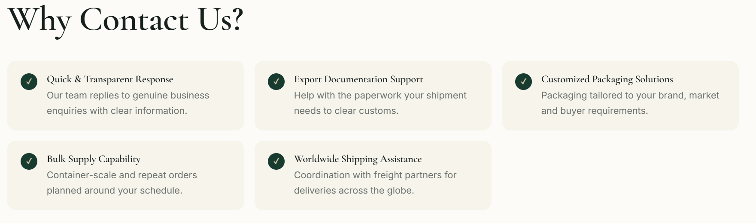
Put this section right beside Contact us form which has just been empty.

Change the colour of this section so this section could look different from footer. Heading should be in one line, then put sub details texts. Aline entire thing in centre. Now put the buttons below aligned left side.
Footer as it is.

